**Introduction to Databases Assignment**

**Table of Contents:**

Part 1 – Retrieving Data using SQL Page 1 - 4

Part 1 A Page 1 - 2

Part 1 B Page 3 - 4

Part 1 C Page 5

Part 2 – Database Design, Implementation and Integrity Page

Part 2 A Page

Part 2 B Page

Part 2 C Page

**Part 1 – Retrieving Data using SQL**

**Part 1 A**

**SQL Code:**

SELECT shopper_first_name, shopper_surname, shopper_email_address, STRFTIME('%d-%m-%Y',date_joined)AS 'Date Joined', ROUND((JULIANDAY(DATETIME('2020-01-01')) - JULIANDAY(date_of_birth)) / 365 -0.5) AS 'Age (in years)'

FROM shoppers

WHERE date_joined >= '2020-01-01'

OR date_of_birth > '1990-01-01'

ORDER BY ROUND((JULIANDAY(DATETIME('2020-01-01')) - JULIANDAY(date_of_birth)) / 365)-0.5 DESC, shopper_surname;

**Explanation of the code:**

The first block of code (the SELECT statement and FROM clause) tells SQLite what to grab (SELECT) from my table. For example, SELECT shopper_email_address would select the shopper_email_address form the table. The line of code “ STRFTIME(‘%d-%m’-%Y, date_joined) AS ‘Date Joined’, is telling SQLite to display the date_joined column data in the format ‘ DD-MM-YYYY’ instead of SQLite’s default option which is to display dates like ‘YYYY-MM-DD’. The “AS ‘Date Joined’ ” part of the code tells SQLite to display the column name as Date Joined rather than “ STRFTIME(‘%d-%m’-%Y, date_joined) ” so that it is easier for users to understand and read it. ROUND((JULIANDAY(DATETIME('2020-01-01')) - JULIANDAY(date_of_birth)) / 365 -0.5) works out how old the shoppers are, and the “ROUND” function at the begging rounds the value to the nearest whole number. The FROM clause tells SQLite to get the data from the shoppers table, for example when I say SELECT shopper_first_name the FROM clause tells SQLite to get that from the shoppers table.

The second block of code (the WHERE and ORDER clause) tells SQLite to only display shoppers who joined in or after the 1st of Jan 2020 or those aged less than 30 on the 1st of Jan 2020. And they tell SQLite to ORDER the results by the “Age (in years)” column in Descending order, and then by shopper_surname.

**Screenshot of the query result:**

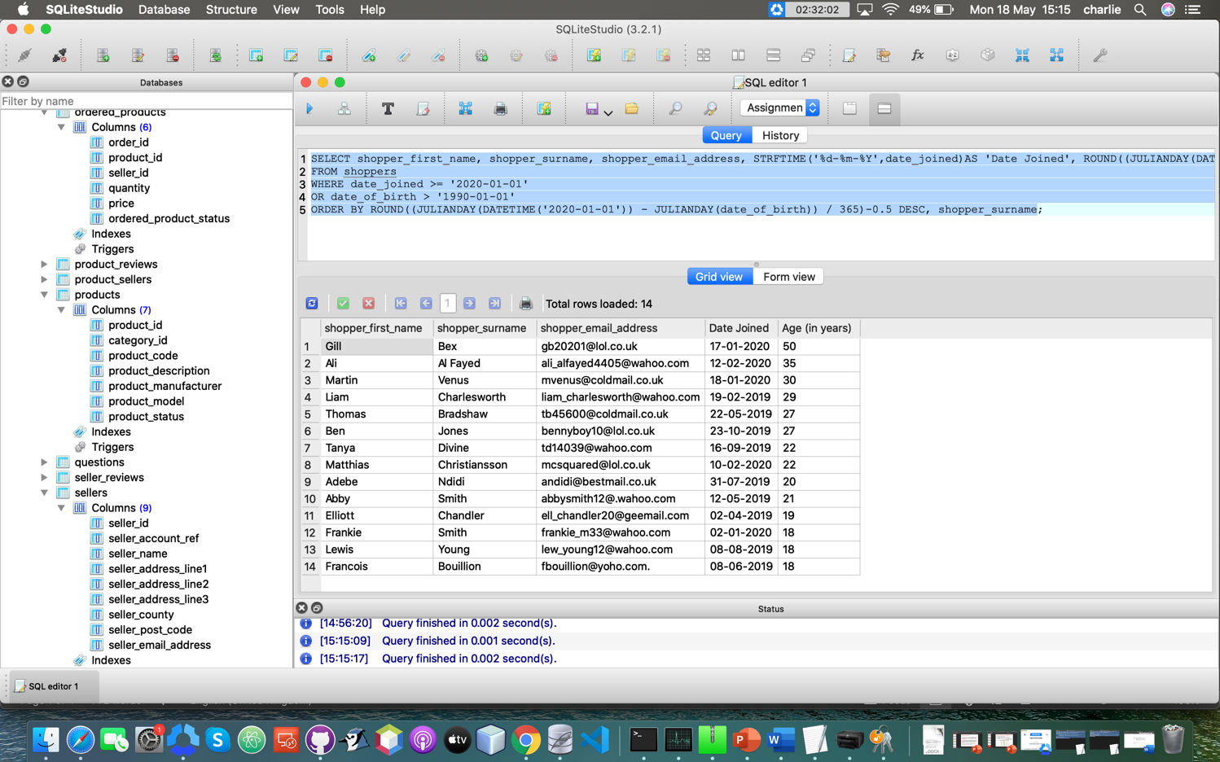

**Testing:**

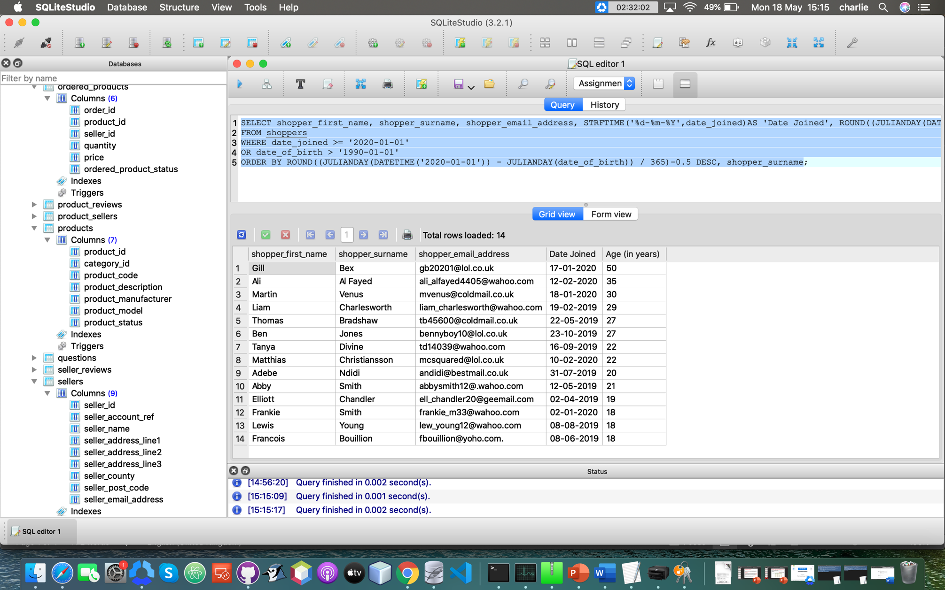

Here you can see that only shoppers who joined on or after the 1st of Jan 2020 OR shoppers who are less than 30 years old on 1st of Jan 2020 are shown, I have done this to meet the user requirements.



As you can see here the “Date Joined” column is displayed in the format “DD-MM-YYY” as opposed to the normal SQLite (default) format “YYYY-MM-DD”, therefore meeting the user requirements.



And finally, you can see in the screenshot above that these results are ordered by the age and the highest is first, this is proved by 50 being at the top and the ages descending after that. After age the results are then ordered by shopper_surname, this is shown by Frankie Smith being above Lewis Young despite them both being the same age, which once again meets the user requirements.

**Part 1 B**

**SQL Code:**

SELECT s.shopper_id, s.shopper_first_name, s.shopper_surname, s.shopper_account_ref, op.order_id, op.ordered_product_status, op.quantity, '£' || ROUND(op.price,2) AS 'price', se.seller_name, pr.product_description, STRFTIME('%d-%m-%Y', so.order_date) AS 'Order Date'

FROM shoppers s

INNER JOIN ordered_products op ON op.order_id = so.order_id

INNER JOIN sellers se ON op.seller_id = se.seller_id

INNER JOIN products pr ON op.product_id = pr.product_id

INNER JOIN shopper_orders so ON op.order_id = so.order_id

AND s.shopper_id = so.shopper_id

WHERE s.shopper_account_ref = @id

ORDER BY so.order_date DESC;

**Explanation of the code:**

The first block of code (the SELECT statement and FROM clause) tells SQLite what to grab (SELECT) from my tables. For example, SELECT op.quantity would select the quantity column form the ordered_products table, as I have assigned a table alias of ‘op’ to ordered_products. The “ ’£’ || ROUND(op.price, 2)” part of the code tells SQLite to display the op.price column data with a pound sign (£) at the beginning and to round the op.price data to two decimal points. The “ AS ‘Price’ ” part of the code tells SQLite to display the column name as “Price” rather than op.price, this is to make the column names easier to read for the users. The

“ STRFTIME(‘%d-%m-%Y’, so.order_date) AS ‘Order Date’ ” part of the code tells SQLite to display the so.order_date column as DD – MM – YYYY rather than the SQL default of YYYY – MM – DD. And to display that column name as ‘Order Date’ rather than ‘STRFTIME('%d-%m-%Y', so.order_date)‘, so that the users can read the column name easier and understand what the column is showing easier. The FROM clause tells SQLite that I want to get the data from the shoppers table, it is also where I assign the table alias of s to shoppers.

The second block of code (the INNER JOINS) tells SQLite what join to use and how to join the tables to each other so that I can SELECT data from multiple tables, like op.price from the ordered_products table and pr.product_description from the products table. This is also where I assign the rest of the tables table aliases, like se for sellers and pr for products.

The last block of code (the WHERE clause and ORDER BY clause) tells SQLite to only show values where the s.shopper_account_ref is the same as what the user has inputted. The ORDER BY clause tells SQLite how to order the results, for this code it tells SQLite to order the results by displaying the most recent order_date first (or displaying so.order_date on descending order (DESC)).

**Screenshots of the query results and user input (if any):**

First instance of user input:

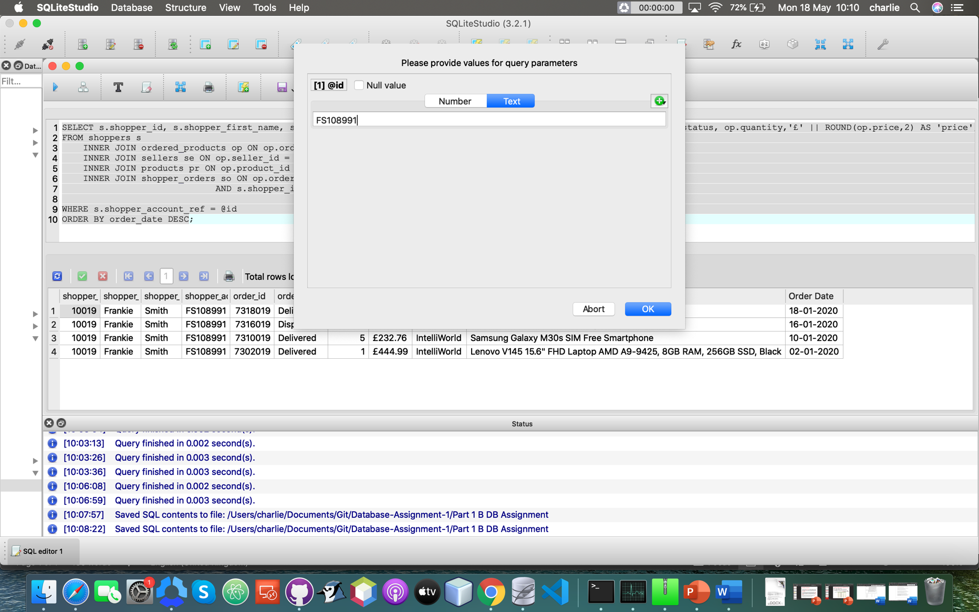

First query results:

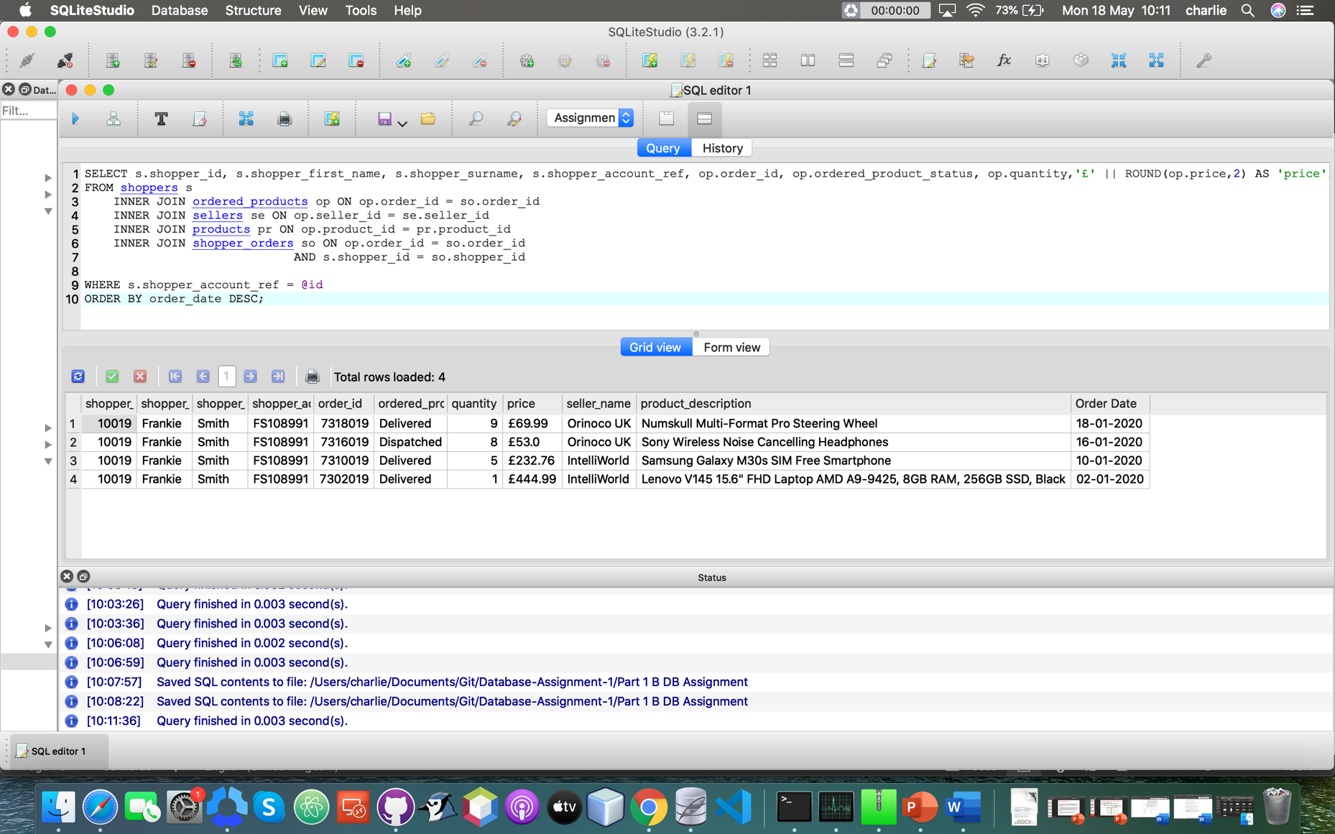

Second instance of user input:

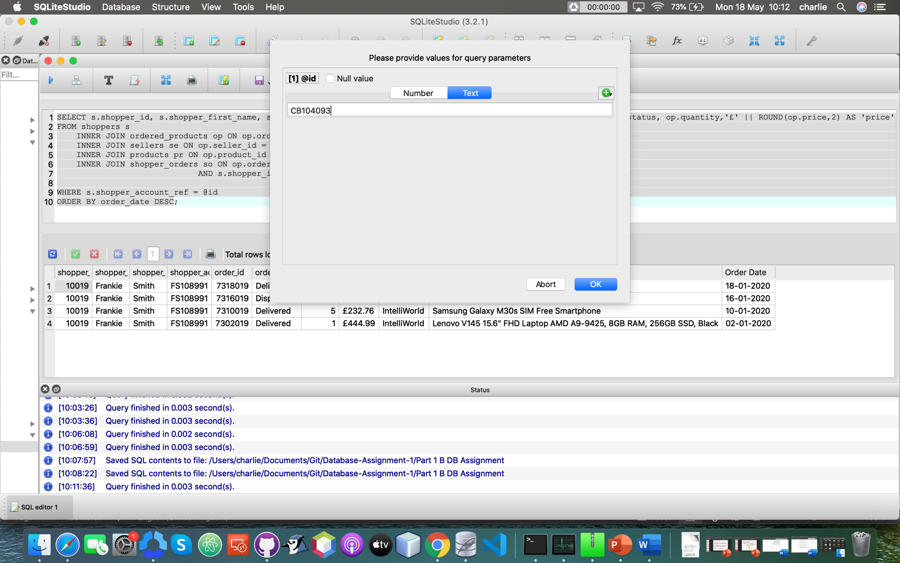

Second query results:

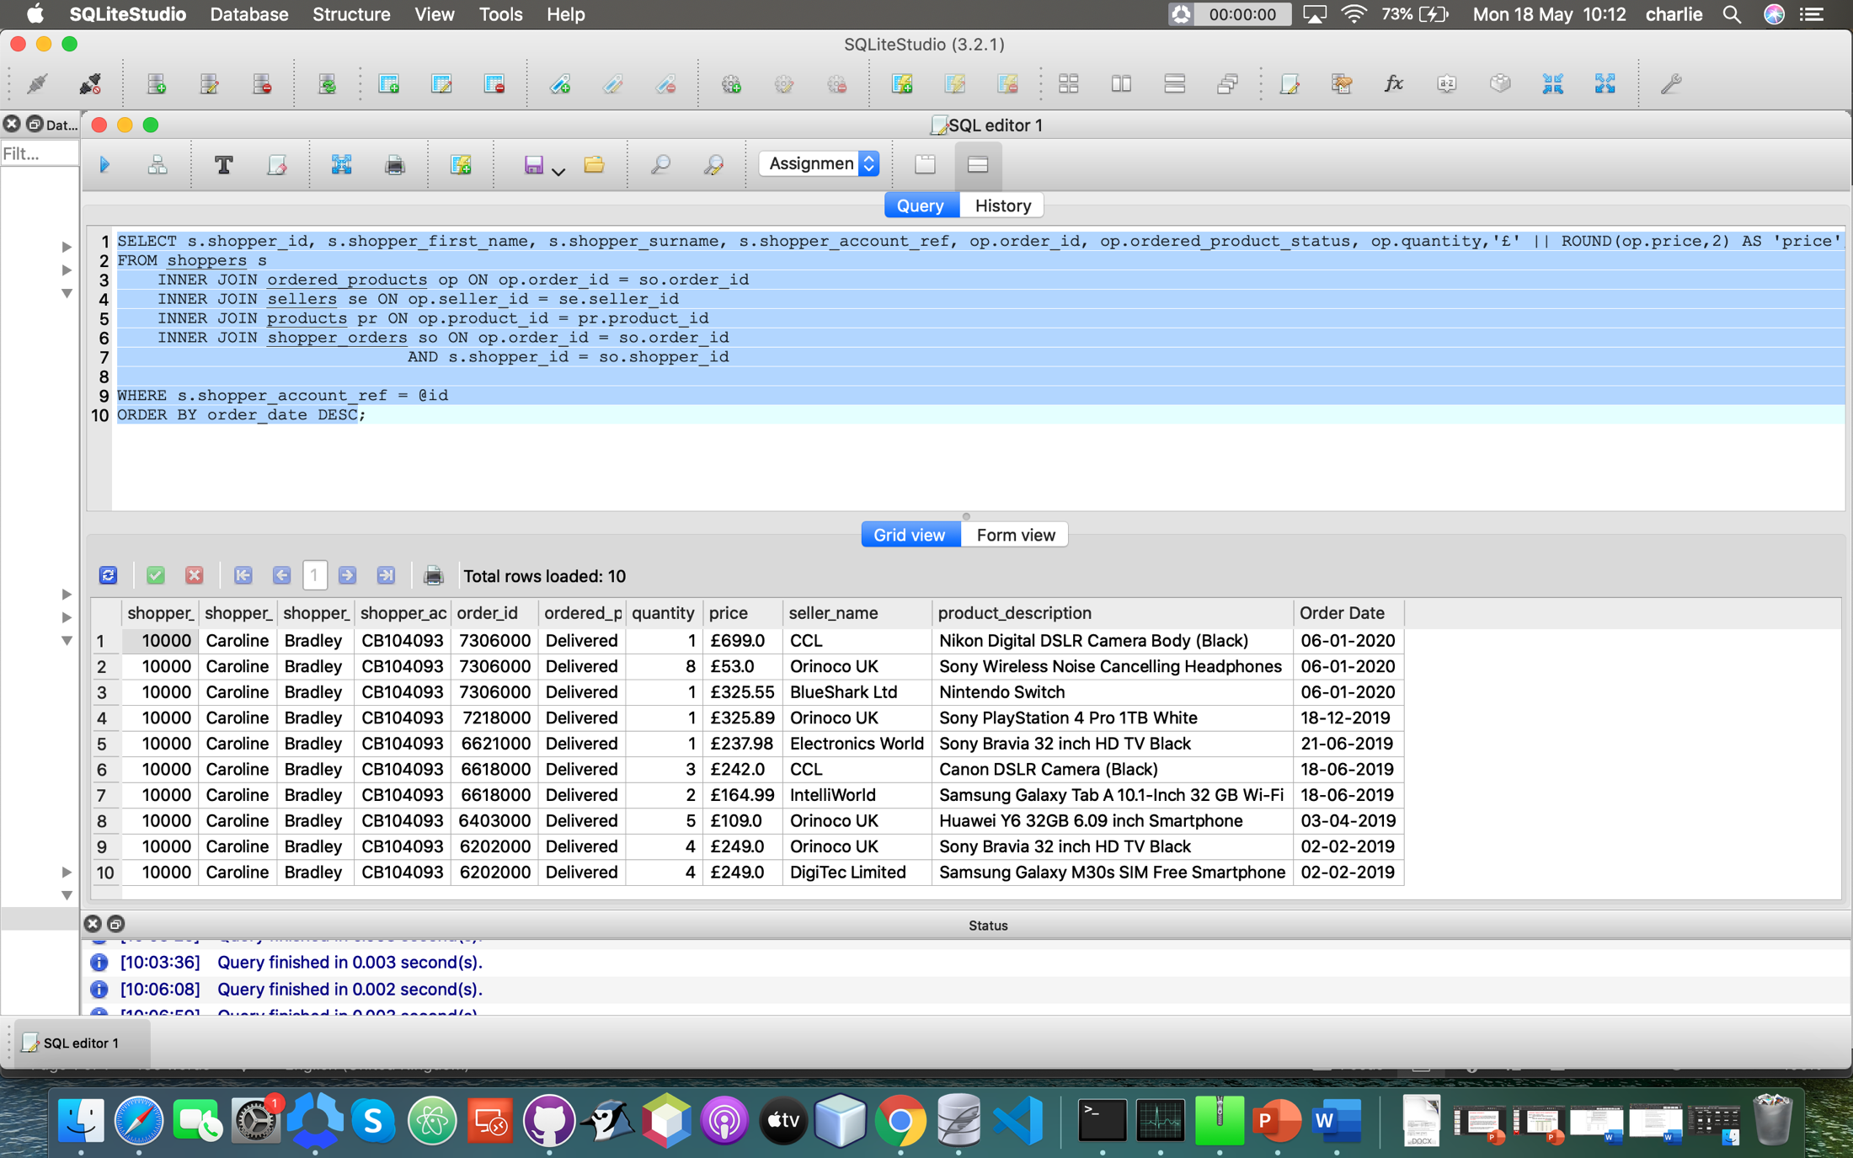

**Testing:**

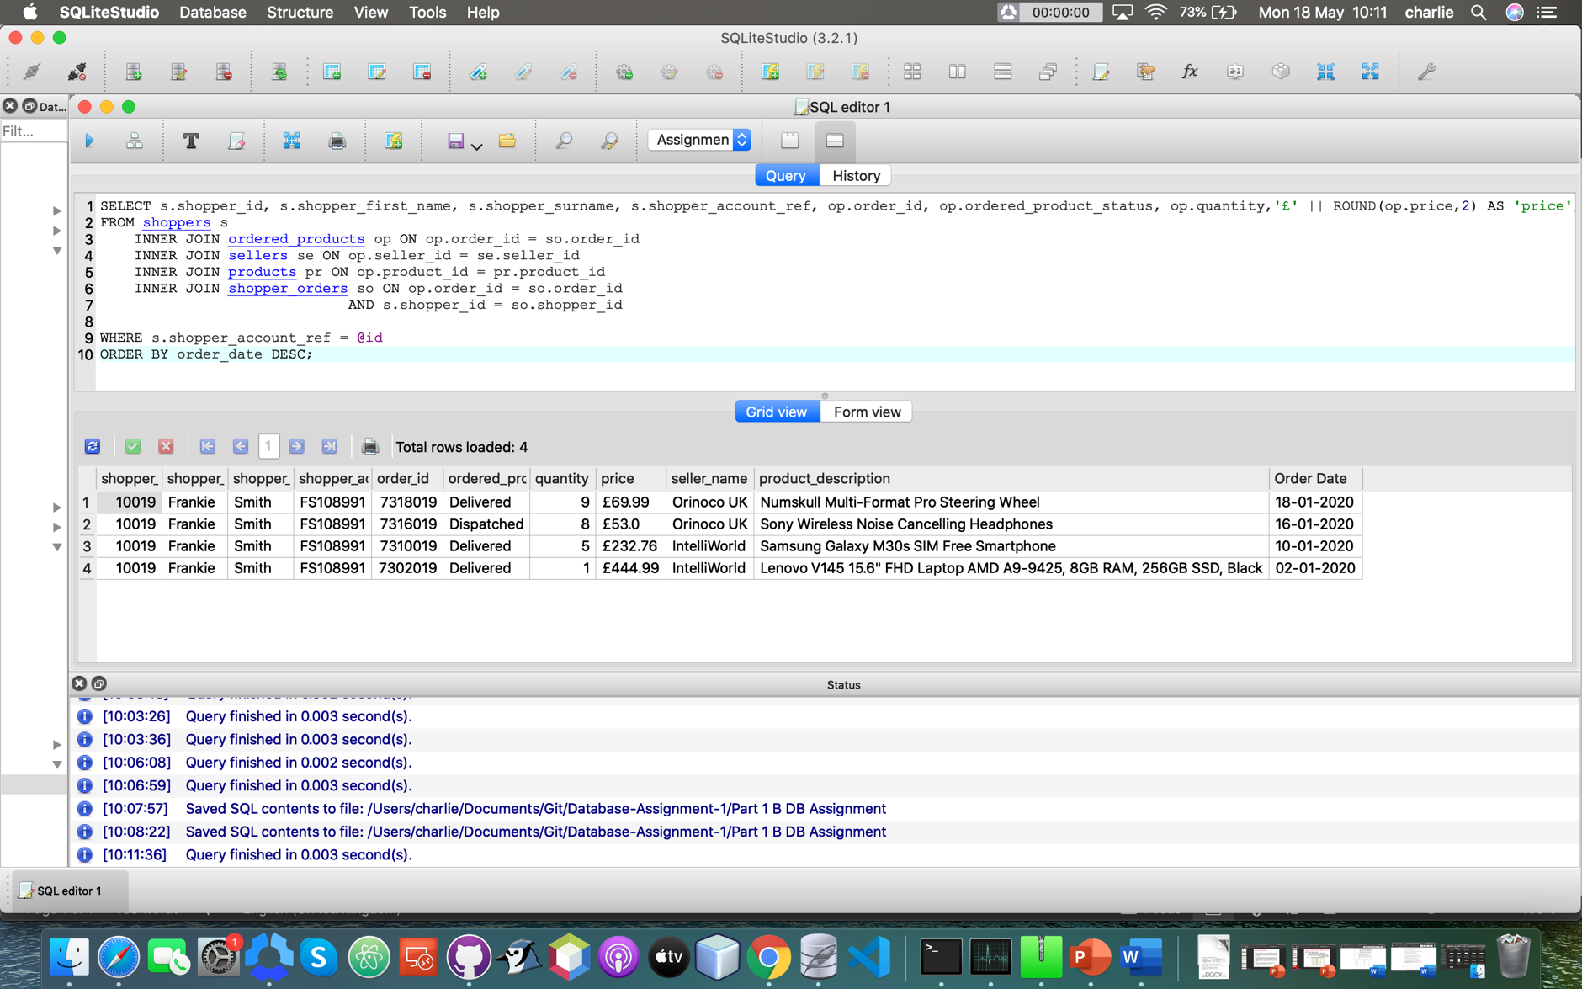

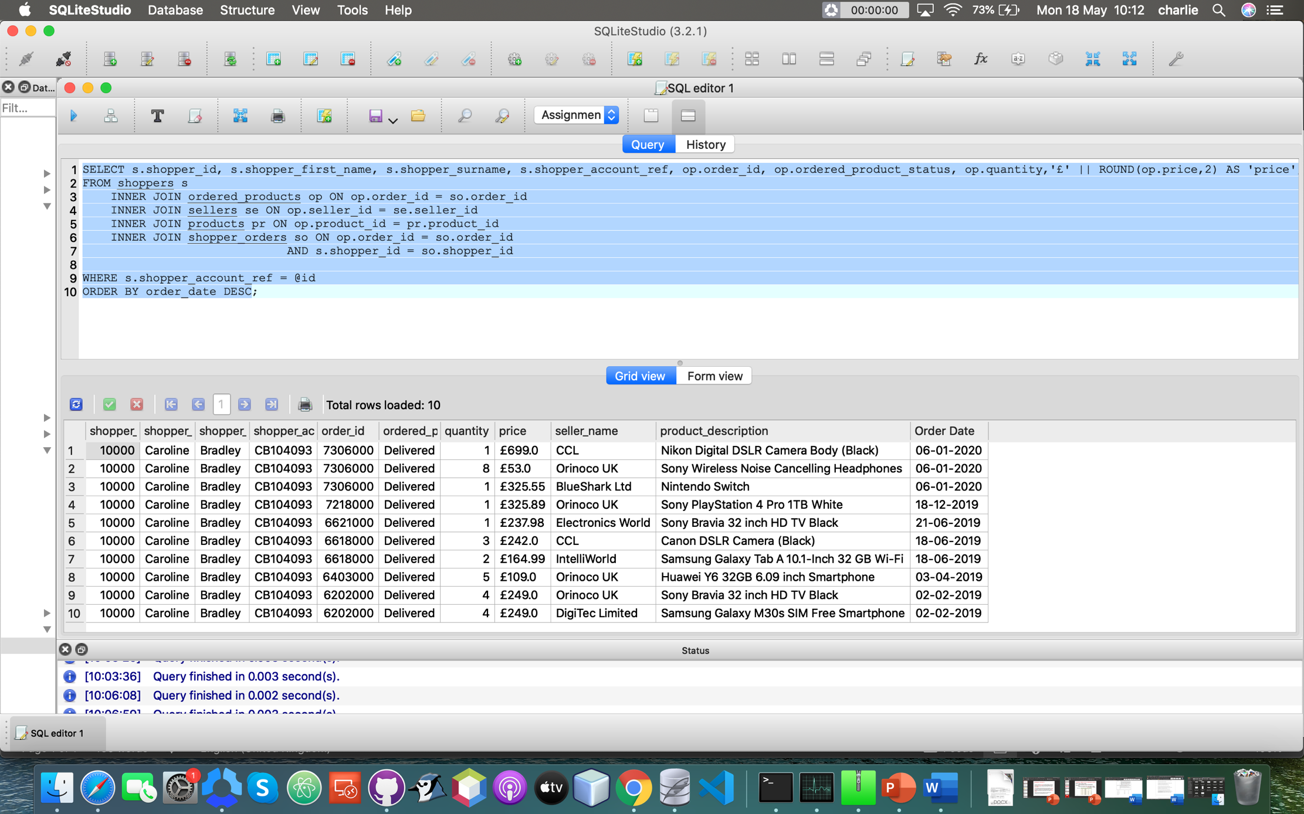

In these two query results you can see the “Order Date” column is displayed in the format ‘DD-MM-YYYY’ instead of SQLite’s default format of “YYYY-MM-DD”, which I have done to meet the user requirements.

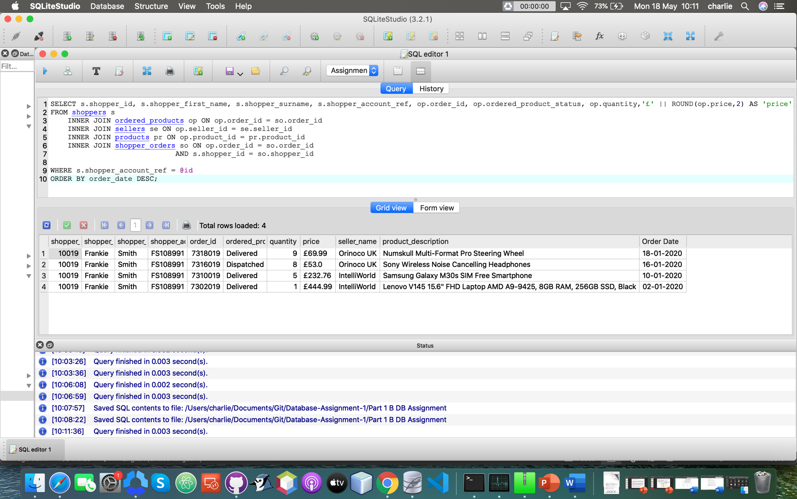



Here you can see that the results are ordered by the “Order Date” column and showing the most recent order first (descending), meeting the user requirements.

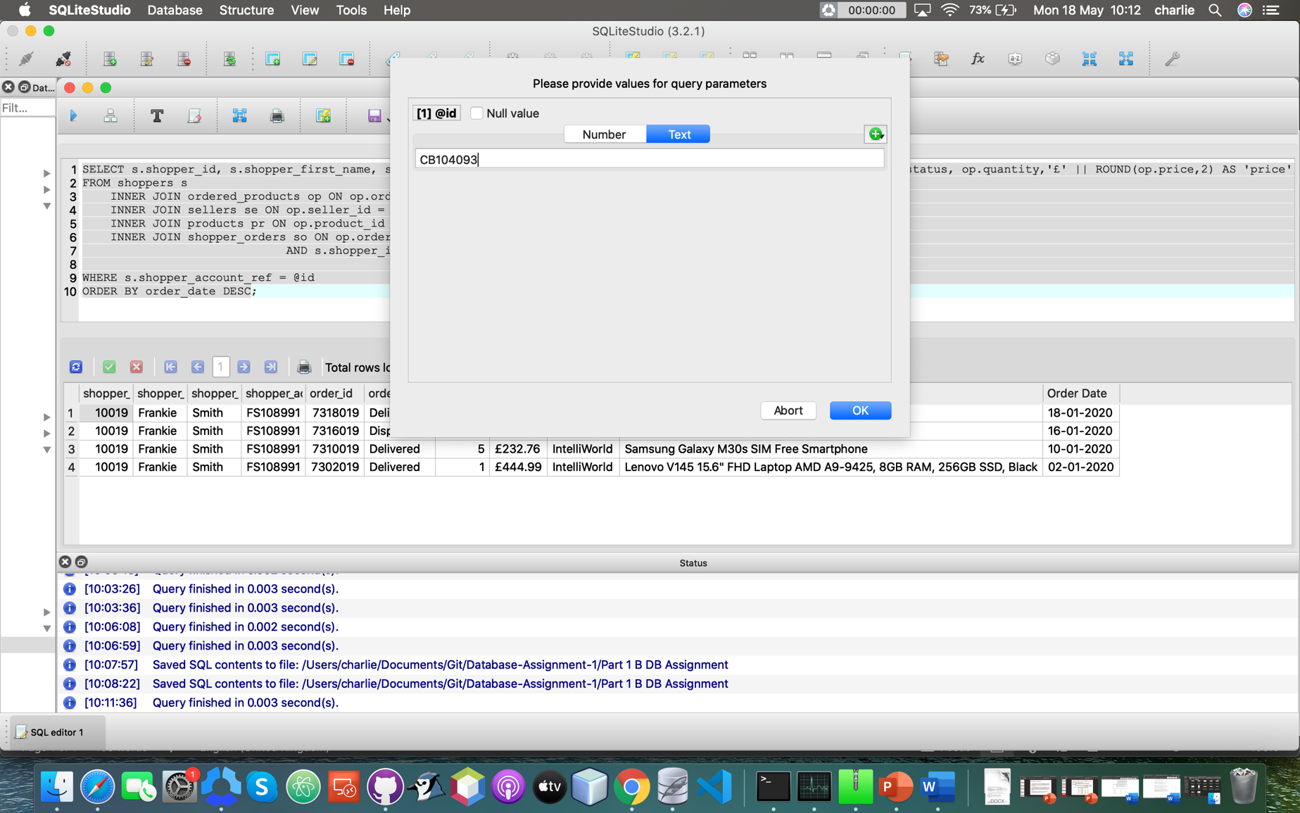

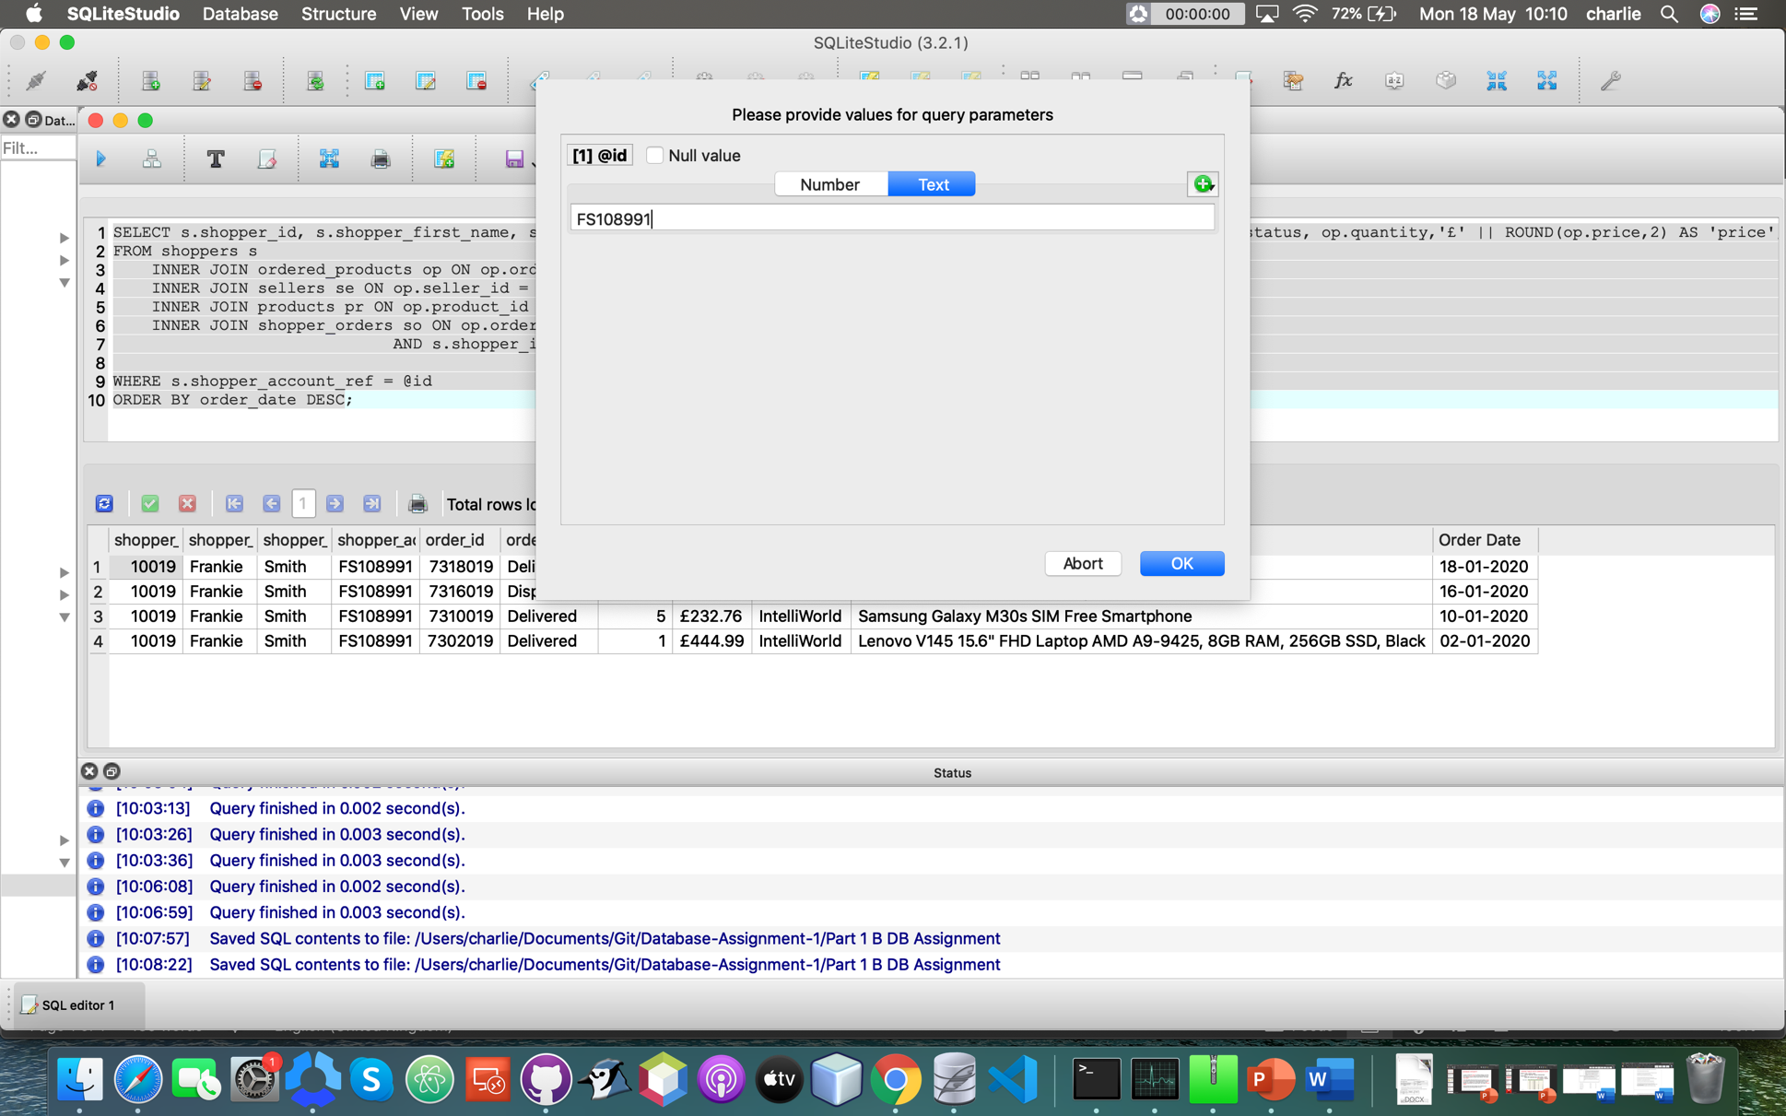

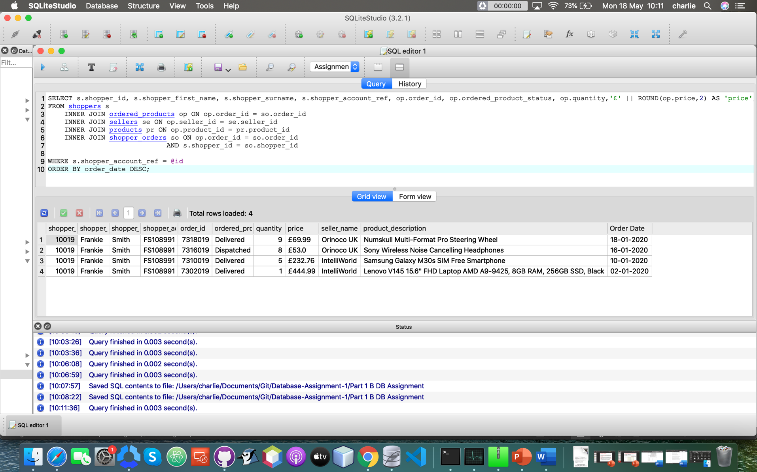

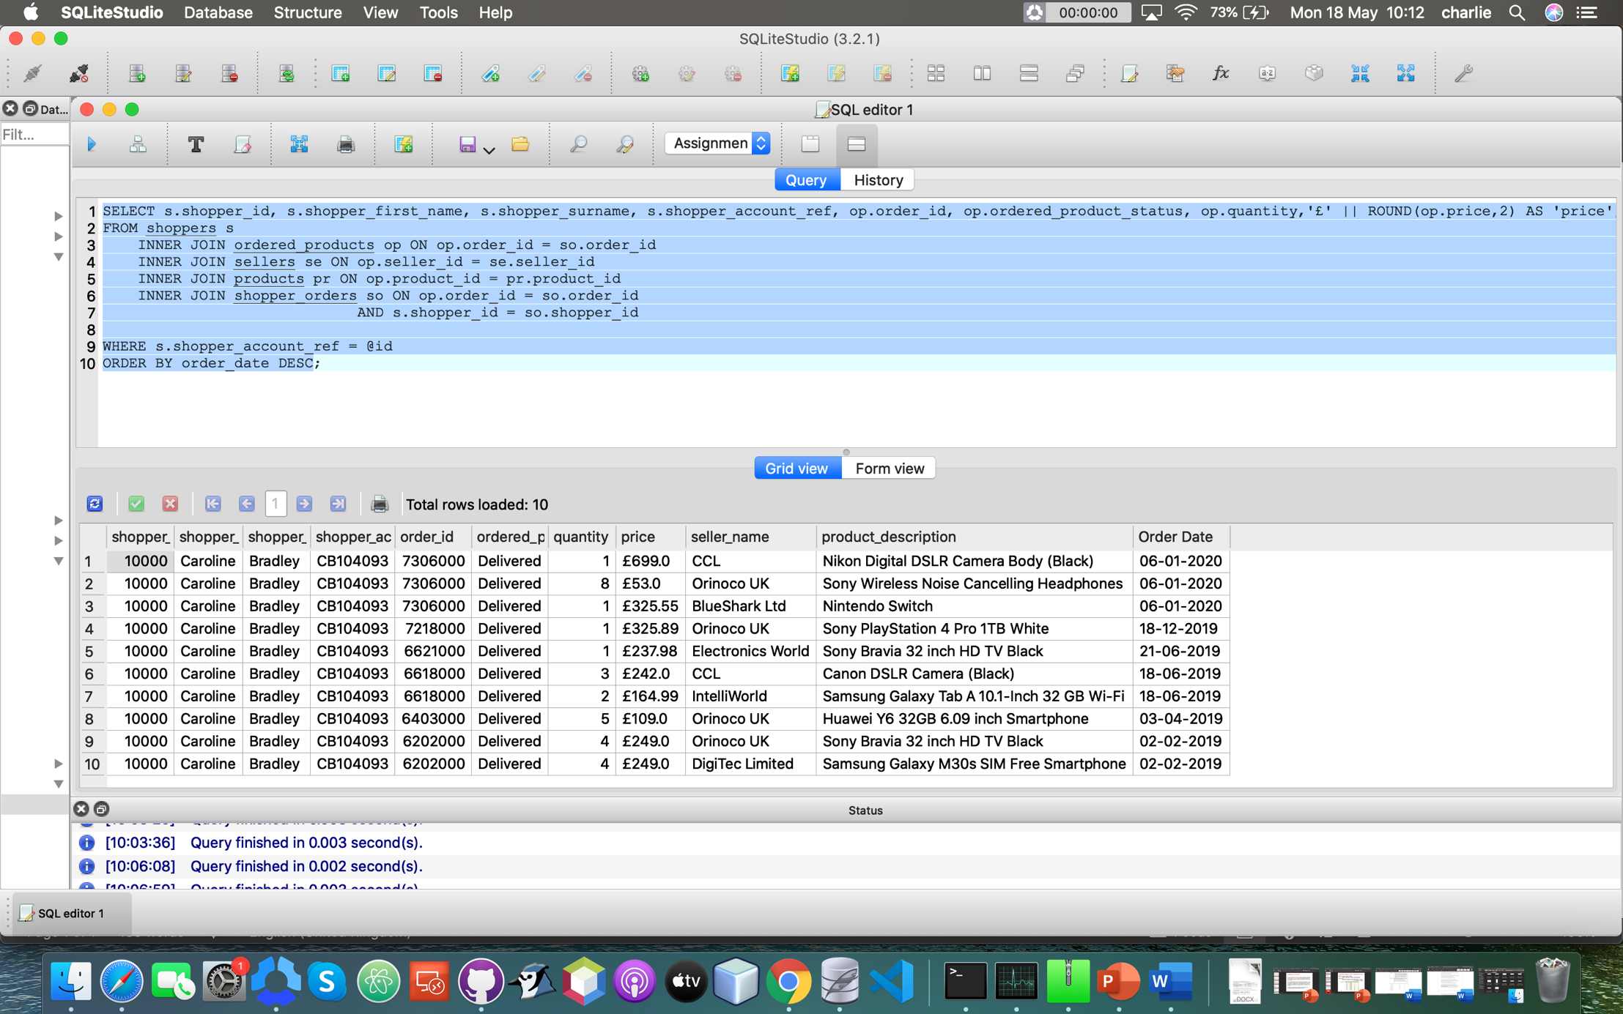

Herr you can see two examples of me prompting the user to enter a shopper’s account ref to display the shopper_ids 10019 & 10000, once again fulfilling the user requirements.

**Part 1 C**

**SQL Code:**

**Explanation of the code:**

**Screenshots of the query results and user input (if any):**

**Part 2 – Database Design, Implementation and Integrity**

**Part 2 A**

**Assignment 1 - Question 2A**

**Conceptual Design:**

**Seller review Entity:**

|  |  |  |  |
| --- | --- | --- | --- |
| **Seller review number** | **Reviews about the sellers** | **Seller star review**  **( * Poor, ** Fair, *** Good,**  **\*\*\*\* Very Good,**  **\*\*\*\*\* Excellent)** | **Date time feedback submitted** |
|  |  |  |  |
|  |  |  |  |
|  |  |  |  |

**Product review Entity:**

|  |  |  |  |
| --- | --- | --- | --- |
| **Product review number** | **Reviews about products** | **Product star review**  **(* Poor, ** Fair, *** Good,**  **\*\*\*\* Very Good,**  **\*\*\*\*\* Excellent)** | **Date time feedback submitted** |
|  |  |  |  |
|  |  |  |  |
|  |  |  |  |

**Question Entity:**

|  |  |
| --- | --- |
| **Question about products** | **Date time question asked** |
|  |  |
|  |  |
|  |  |

**Answer Entity:**

|  |  |
| --- | --- |
| **Answers for the questions** | **Date time answers posted** |
|  |  |
|  |  |
|  |  |

Here are the three entities that will be used in my table design to store the additional information needed from the requirements.

**High-level entity relationship diagram (ERD):**

Product Review

Sellers

Products

Seller

review

Answer

Question

This is a basic high level entity relationship diagram that I will use for my table design.

**Logical Design:**

Here I assign a primary key to each of my entities:

**Seller review entity:**

|  |  |  |  |
| --- | --- | --- | --- |
| **Seller review number** | **Reviews about sellers** | **Seller star review**  **(* Poor, ** Fair, ***Good,**  **\*\*\*\* Very Good,**  **\*\*\*\*\* Excellent)** | **Date time feedback submitted** |
|  |  |  |  |
|  |  |  |  |
|  |  |  |  |

In this entity I didn’t have anything that was unique to the Seller reviews entity, so I added a new INTEGER column and made that the primary key (Seller review number).

**Product review entity:**

|  |  |  |  |
| --- | --- | --- | --- |
| **Product review number** | **Reviews about products** | **Product star review**  **(* Poor, ** Fair, *** Good,**  **\*\*\*\* Very Good,**  **\*\*\*\*\* Excellent)** | **Date time feedback submitted** |
|  |  |  |  |
|  |  |  |  |
|  |  |  |  |

Like with the previous entity I did not have anything that was unique to the product reviews entity, so I added a new INTEGER column and made that the primary key (Product review number).

**Question entity:**

|  |  |  |
| --- | --- | --- |
| **Question number** | **Question about products** | **Date time question asked** |
|  |  |  |
|  |  |  |
|  |  |  |

I also did the same thing here that I did for the previous two entities as, again, there were no pre-existing columns in this entity that were fit to be the primary key, so I created one (Question number).

**Answer entity:**

|  |  |  |  |
| --- | --- | --- | --- |
| **Answer number** | **Answers for questions** | **Date time answers posted** | **Question number** |
|  |  |  |  |
|  |  |  |  |
|  |  |  |  |

And finally, I did the same thing here that I did for the previous entities as there were no pre-existing columns in this entity that were fit to be the primary key, so I made one (Answer number).

**Final Logical Design:**

Here is a more in depth ERD for the logical design of my tables, with the primary keys underlined and foreign key marked with an asterisk (*).

Product Review

Sellers

Products

Seller review

Answer

Question

Seller review number

Review about seller

Seller star rating

Date time feedback submitted

Seller_id

Seller_account_ref

Seller_name

Seller_address_line1

Seller_address_line2

Seller_address_line3

Seller_county

Seller_post_code

Seller_email_address

Product review number

Reviews about_products

Product star rating

Date time feedback submitted

Product_id

*Category_id

Product_code

Product_description

Product_status

Question number

Questions about products

Date time question asked

Answer number

Answers for questions

Date time answer posted

*Question number

**Physical Design:**

**Seller review table:**

|  |  |  |  |
| --- | --- | --- | --- |
| **Review**  **_number** | **Reviews_about**  **_sellers** | **Seller_star_review**  **(* Poor, ** Fair, *** Good,**  **\*\*\*\* Very Good,**  **\*\*\*\*\* Excellent)** | **Date_time_feedback**  **_submitted** |
|  |  |  |  |
|  |  |  |  |
|  |  |  |  |

I will add a CHECK constraint on the Date_time_feedback_submited column to ensure that it only accepts dates in this format: DD/MM/YYYY, and time in this format: HH/MM/SS.

As well as this I will add a CHECK constraint on the Reviews_about_sellers column to ensure that only VARCHAR data types can be inputted into them and no other data type (i.e, INTEGER, FLOAT, BOOLEAN etc.)

Also I will add a CHECK constraint on the Date_time_feedback_submitted column to ensure that only DATETIME data types can be inputted into it and no other data type (i.e, VARCHAR, FLOAT, BOOLEAN, INTEGER etc.)

I will also use another CHECK constraint on the Reviews_about_sellers column to ensure that no more than 5 *’s are inputted and at least 1 * is inputted to ensure that anyone who reviews a seller does so in the correct way.

The primary key will increase automatically by one every time another piece of data is added to the table, and it will never change as to keep it unique.

**Product review table:**

|  |  |  |  |
| --- | --- | --- | --- |
| **Review number** | **Reviews_about**  **_products** | **Product star review**  **(* Poor, ** Fair, *** Good,**  **\*\*\*\* Very Good,**  **\*\*\*\*\* Excellent)** | **Date_time**  **_feedback**  **_submitted** |
|  |  |  |  |
|  |  |  |  |
|  |  |  |  |

I will add a CHECK constraint on the Date_time_feedback_submited column to ensure that it only accepts dates in this format: DD/MM/YYYY, and time in this format: HH/MM/SS.

As well as this I will add a CHECK constraint on the Reviews_about_products column to ensure that only VARCHAR data types can be inputted into them and no other data type (i.e, INTEGER, FLOAT, BOOLEAN etc.)

Also I will add a CHECK constraint on the Date_time_feedback_submitted column to ensure that only DATETIME data types can be inputted into it and no other data type (i.e, VARCHAR, FLOAT, BOOLEAN, INTEGER etc.)

I will add another CHECK constraint to make sure that if the Reviews_about_products column has data in it, then so must the Date_time_feedback_submitted column.

I will also use another CHECK constraint on the Reviews_about_products column to ensure that no more than 5 *’s are inputted and at least 1 * is inputted to ensure that anyone who reviews a product does so in the correct way.

Like the seller reviews entity the primary key will automatically increase by one every time another piece of data is added to the table, and it will never change as to keep it unique.

**Question table:**

|  |  |  |
| --- | --- | --- |
| **Question_number** | **Questions_about_products** | **Date_time_questions_asked** |
|  |  |  |
|  |  |  |
|  |  |  |

I will add a CHECK constraint on the Questions_about_products column to ensure that only VARCHAR can be inputted into it and no other data type (i.e, INTEGER, FLOAT, BOOLEAN etc.)

As well as a CHECK constraint on the Date_time_questions_asked to ensure that only DATETIME data types can be inputted into it and no other data type (i.e, TEXT, FLOAT, BOOLEAN etc.)

I will also add a CHECK constraint on the Date_time_questions_asked column to ensure that it only accepts dates in this format: DD/MM/YYYY, and time in this format:

HH/MM/SS.

I will also add a CHECK constraint to make sure that if the Questions_about_products column has data in it, then so must the Date_time_questions_asked column.

Like with the previous tables, the primary key will also increase automatically by one every time another piece of data is added to the table and it will never change as to keep it unique.

**Answer table:**

|  |  |  |  |
| --- | --- | --- | --- |
| **Answer_number** | **Answers_for_questions** | **Date_time_answers_posted** | **Question_number** |
|  |  |  |  |
|  |  |  |  |
|  |  |  |  |

I will add a CHECK constraint on the Date_time_answers_ posted column to ensure that it only accepts dates in this format: DD/MM/YYYY, and time in this format: HH/MM/SS

I will also add a CHECK constraint on the Date_time_answers_ posted to ensure that only INTEGER data types can be inputted into it and no other data type (i.e, TEXT, FLOAT, BOOLEAN etc.)

As well as a CHECK constraint on the Answers_for_questions column to ensure that only TEXT can be inputted into it and no other data type (i.e, INTEGER, FLOAT, BOOLEAN etc.)

I will also add a CHECK constraint to make sure that if the Answers_for_questions column has data in it, then so must the Date_time_answers_posted column to ensure that every answer has a date and time it was posted.

Like with the other tables the primary key will also increase automatically by one every time another piece of data is added to the table, and it will never change as to keep it unique.

**Physical Design:**

Product Reviews

Sellers

Products

Seller reviews

Answers

Questions

Seller_review_number

Review_about_seller

Seller_star_rating

Date_time_feedback_submitted

Seller_id

Seller_account_ref

Seller_name

Seller_address_line1

Seller_address_line2

Seller_address_line3

Seller_county

Seller_post_code

Seller_email_address

Product_review__number

Reviews_about_products

Product_star_rating

Date_time_feedback_submitted

Product_id

*Category_id

Product_code

Product_description

Product_status

Question_number

Questions_about_products

Date_time_question_asked

Answer_number

Answers_for_questions

Date_time_answer_posted

*Question_number

Here the entity titles have been pluralized to create the table name, e.g Seller review to Seller reviews. And any spaces in the column names are replaced by an underscore.

**Final Physical Design:**

This is the final Physical Design of my table with the data types included in it as well as foreign (indicated with an asterisk (*)) and primary keys (primary keys are underlined).

Product Review

Sellers

Products

Seller review

Answers

Questions

Seller_review_number INTEGER

Review_about_seller TEXT

Seller_star_rating INTEGER

Date_time_feedback_submitted TEXT

Seller_id INTEGER

Seller_account_ref VARCHAR

Seller_name TEXT

Seller_address_line1 VARCHAR

Seller_address_line2 VARCHAR

Seller_address_line3 VARCHAR

Seller_county TEXT

Seller_post_code VARCHAR

Seller_email_address VARCHAR

Product_review__number INTEGER

Reviews_about_products TEXT

Product_start_rating INTEGER

Date_time_feedback_submitted TEXT

Product_id INTEGER

*Category_id INTEGER

Product_code VARCHAR

Product_description TEXT

Product_status TEXT

Question_number INTEGER

Questions_about_products TEXT

Date_time_question_asked TEXT

Answer_number INTEGER

Answers_for_questions TEXT

Dat_time_answer_posted TEXT

*Question_number INTEGER

**Part 2 B**

**Part 2 C**